Omnium

Project Plan

Version 1.0

23 February 2026

Release Checklist

Checklist Item | Control (Yes/No)
The document has passed the quality assurance process. | YES
The document is visually appealing and has a professional look and structure. | YES
All placeholders such as text within <> are replaced with appropriate text. | YES
The document is prepared in the “Justify Text” format. | YES
The document does not include typos, different fonts, and misalignments. | YES
In the revision history, the first version states “The first version”. Additional versions include an entry highlighting all the changes from the previous version. | YES
The table of contents (TOC) is updated as necessary. | YES
References list other project documents and additional standards or documents needed to understand the document. The references include the necessary document/artifact version number and publication date. | YES
The language grammar is used appropriately. | YES
Sentences are written as full sentences. | YES
The wording in the document is formal. | YES
The wording in the document is clear. | YES
The wording in the document is professional. | YES
All project-related definitions, acronyms, and abbreviations sections are included in the related tables. | YES
The team member names are specifically spelled out in the document preparation and approvals sections. | YES
The purpose and scope of the document are adequately described. | YES
All sections include the necessary and adequate information. | YES
The business goals are about how to secure the team/company's place in the market. The product goals are about all the goals of the product. The quality goals list all the product quality attributes for the product. | YES
The deliverables list all the deliverables including all project artifacts (document, code, presentation, etc). | YES
The project risks appropriately and in full sentences. | YES
The work package table is completed with all necessary fields. | YES

Final Control | Yes/No
The document is checked based on the “Team Project Artifacts Common Errors” Guideline. The document is ready for release. | YES
The document is not ready for release. | NO

Document Preparation
Name | Role | Approval (Signature) | Approval Date
Ayesha Khan | Project Technical Manager | Ayesha Khan | 02/23/2026
Eli Ventura | Project Configurations Manager | Eli Ventura | 02/23/2026
Michaela Montelongo | Project Quality Assurance Manager | Michaela Montelongo | 02/23/2026
Hector Marrero-Colominas | Project Manager | Hector Marrero-Colominas | 02/23/2026

Document Approvals
Name | Role | Approval (Signature) | Approval Date
Ayesha Khan | Project Technical Manager | Ayesha Khan | 02/23/2026
Eli Ventura | Project Configurations Manager | Eli Ventura | 02/23/2026
Michaela Montelongo | Project Quality Assurance Manager | Michaela Montelongo | 02/23/2026
Hector Marrero-Colominas | Project Manager | Hector Marrero-Colominas | 02/23/2026

Revision History
Date | Version | Description | Author
02/23/2026 | 1.0 | The first draft | Ayesha Khan  Eli Ventura  Michaela Montelongo  Hector Marrero-Colominas

Table of Contents
1. Introduction 6
1.1 Purpose of the Document 6
1.2 Scope of the Document 6
1.3 References 6
1.4 Definitions, Acronyms, and Abbreviations 6
2. Project Goals 7
2.1 Business Goals 7
2.2 Product Goals 7
2.3 Quality Goals 7
3. Project Stakeholders and Stakes 7
3.1 Summary of Key Stakeholder or User Needs 7
4. Project Budget 7
5. Project Milestones and Schedule 8
6. Project Communications 8
7. Project Members and Roles 9
8. Project Work Breakdown Structure (WBS) 10
9. Project Deliverables 12
10. Project Risks 12
11. Project Software Tools 13
11.1 List of Project Software Tools 13
11.2 Screenshots of Project Software Tools 14

Project Plan

Introduction

Purpose of the Document

The purpose of the Project Plan (PP) is to provide a development structure to the QuantumShell team by describing the goals, needs, and milestones of the Omnium project. This document is provided to aid the team as a guideline for the development of the Omnium day-trading software. The document will be iteratively updated as the project progresses, thus also providing a record of the QuantumShell’s decision-making processes, as well as further serving as a guide for the development team as changes are made.

Scope of the Document
The scope of this document includes descriptions of the project goals, deliverables, project risks, stakeholder needs, and user needs of the Omnium application. Information of the project budget is also described to provide guidance on the monetary investment and man-hours that the Omnium application shall require. Additionally, this document details other essential checkpoints of the project, such being the development cycle of the Omnium application; the communications media utilized by the team for internal communications; and a description of each member’s role in the project. A Work Breakdown Structure (WBS) that the project shall abide by is also provided in this document, as well as further insight into the third-party software tools that the team shall use during the development of the Omnium project.

References
Reference Title/Name | Date | Version
MIL-STD-498 | 12/5/1994 | N/A
IEEE/ISO/IEC 15288-2023  ISO/IEC/IEEE International Standard - Systems and software engineering--System life cycle processes | 05/16/2023 | 2023
IEEE/ISO/IEC 15289-2019  ISO/IEC/IEEE International Standard -- Systems and software engineering - Content of life-cycle information items (documentation) | 07/19/2019 | 2019
Project Vision Document (PVD) | 02/13/2026 | 1.0

Definitions, Acronyms, and Abbreviations

Term | Abbreviation / Acronym | Definition
Omnium | N/A | Omnium is the name of the modular day trading platform developed in this project.
Project Description Document | PDD | The project description document is the project document detailing the project to be completed.
Project Vision Document | PVD | The project vision document is the project document describing the project vision to be accomplished.
Work Breakdown Structure | WBS | A Work Breakdown Structure (WBS) is a hierarchical decomposition of a project into smaller, more manageable components.
Computer Science Rule-Based Structure | CS-Module | CS-Module is an automated trading module that uses a classic computer science algorithm for making trading decisions.
Machine Learning Based Module | ML-Module | ML-Module is an automated trading module that uses a machine learning algorithm for making trading decisions.
Back-Testing | N/A | Back-testing is the process of evaluating a trading strategy by applying it to historical market data to assess how it would have performed.
Paper Trading | N/A | Paper trading refers to simulated trade execution using real or historical market data without financial risk.
Live Trading | N/A | Live trading refers to the execution of trades using a real brokerage account with actual financial impact.
Plug-and-Play | PnP | Plug-and-play refers to the modular design principle where system components can be added, removed, or replaced without affecting the rest of the system.
Orchestrator | N/A | The orchestrator is the central module responsible for coordinating data flow and command execution between all other modules in the Omnium system.
High-Frequency Trading | HFT | High-frequency trading is a type of trading that is defined by high turnover rates and taking advantage of short-term fluctuation in financial markets. It is characterized by its reliance on algorithms and electronic tools in order for trades to be closed out.

Project Goals

Business Goals
The business goals set for the Omnium project are to make a foothold in the day trading application market by making a product that encompasses the usual functions desired for trading along with others. With no staple product used in the market, it gives QuantumShell an opportunity to insert the Omnium application in to try to provide an environment for practicing day-trading as well as performing live trading with the product.

Product Goals
The product that QuantumShell has set out to create is intended to be a day-trading platform that offers various ways to operate in the day-trading market via the operation of a “Paper Trading Mode” and “Live Trading Mode”. On top of that, QuantumShell shall aim for Omnium to be an application that can be used in an educational way by providing a way for hobbyists, computer scientists, and others to learn about algorithmic trading.

Quality Goals
When it comes to quality, QuantumShell will strive to have the Omnium product run smoothly with an easy-to-navigate UI. Other goals include achieving as little errors as possible upon showcasing. While a product like this is bound to have errors and network latency due to its real-time tracking, QuantumShell plans to cut them down to a minimum throughout the development process.

Project Stakeholders and Stakes
This section provides a brief overview of the stakeholders and users involved in the Omnium project and the key problems that they perceive to be addressed by QuantumShell's proposed solution. Further details on the stakeholders' requirements can be found in the Project Vision Document (PVD).

Summary of Key Stakeholder or User Needs
Day-trading is a high-risk financial endeavor that is pursued by seasoned traders or hobbyists who have built a long-term familiarity with financial markets. This is due to the nature of day-trading as a high-pressure, time-locked activity where the user must make rapid decisions before the day market closes out. Users must be able to quickly identify opportunities for arbitrage in order to produce financial gain from these short-term market changes.

Omnium provides an application that offers a Paper-Trading mode that guides and introduces users to the world of financial markets through on-screen tutorials, walkthroughs and guides. Trends are described to the user as well as details about historical market trends. The Paper-Trading mode offers a financially safe environment for the user to practice trading and to build a baseline of familiarity with short-term market trends.

For more experienced and comfortable traders, a Live-Trading mode offers an environment to trade securities and close out their positions by the end of the day. It shall provide a secure application with virtually zero latency to allow its users to secure a trade before it fluctuates. This is a critical component that is essential for the high-frequency traders (HFTs) that will be utilizing the platform; 43.1% of traders polled stated that “latency” was their greatest limitation and concern in their current trading infrastructure. Omnium will provide one singular environment with consistent network speeds to allow day-traders to utilize the platform’s market analysis, data visualizations, statistical modeling, and transactions for their operations.

Project Budget
The project is developed by the QuantumShell team, which consists of 7 members, each of whom contributes at least 4 hours a week to the project. As the project development cycle is capped at 12 weeks, the project man-hours are calculated to be at least 336 hours, which is found from the following equation:
7 members * 4 hours of labor * 12 weeks of project development cycle = 336 man-hours
An itemized list of the budget components can be found below:
Project Meetings:
7 members * 0.75 hours of labor * 12 weeks of project development cycle = 63 man-hours
Project Technical Documentation:
7 members * 1 hours of labor ** 12 weeks of project development cycle = 84 man-hours
Project Development:
7 members * 2 hours of labor * 12 weeks of project development cycle = 168 man-hours
Project Testing and Debugging:
The remaining 21 man-hours of the project will be spent on automated testing and debugging of the Omnium software.

Project Milestones and Schedule
Project Start Date: January 20, 2026
Project End Date: April 24, 2026
Project Milestone | Date | Deliverable
Problem Analysis, Vision Creation, Project Planning | 2/23/2026 | Product Vision Document  Project Plan
Requirements Analysis | 2/27/2026 | Software Requirements Specification (SRS)
Product Design | 3/27/2026 | Software Design Document (SDD)
Product Implementation | 4/15/2026 | Software Code
Product Test | 4/3/2026 | Software Test Document (STD)
Final Product Deliverable | 4/15/2026 | All Documentation and Code
Product Launch | 4/15/2026 | Project Presentation

Project Communications
Project Communication Type | Responsible Team Member | Receiving Stakeholder | Frequency | Medium | Scheduled Time
Daily Project Communication | Any Team Member | Any Team Member | Anytime | Discord | Anytime
Meetings | Project Manager | All Team Members | Twice a Week | Face-to-face / Discord | Every Tuesday 12:30 – 1:30  Every Friday 1:30 – 3:00
Project Check-ins | Project Technical Manager | All Team Members | Anytime | Discord | Anytime

Project Members and Roles
Project Role | Name | Responsibilities
Project Manager | Hector Marrero-Colominas | The project manager is responsible for all aspects of the project development such as creating a project team, ensuring that the project vision becomes a reality, and managing all aspects of the project related to turning the project vision into reality. The project manager is also responsible for submission of project documents, project code, and all other artifacts on time with the necessary quality.
Project Technical Manager | Ayesha Khan | The project technical manager is the primary assistant of the project manager, especially in all project’s technical aspects. The project technical manager coordinates all technical aspects of the project including requirements of development, design development, code development, testing, quality assurance, and configuration management.
Project Requirements Manager | Joseph Duff | The project requirements manager is responsible for managing all requirements-related activities under the guidance of the project manager and technical manager. The project requirements manager prepares the requirements, use cases, and requirements documents, and ensures that the requirements are correctly coded, and the test cases test the requirements and the product.
Project Design Manager | Andrew Tamez | The project design manager is responsible for researching and identifying suitable software architecture for the product. The project design manager manages all backend and frontend design activities and ensures that product design is of adequate quality in line with product quality goals.
Project Test Manager | Brady Bottari | The project test manager is responsible for conducting all activities related to project testing such as creating a test strategy, preparing the testing environment, preparing testing-related documents and artifacts, reporting the test results, and bug and defect tracking.
Project Configuration Manager | Eli Ventura | The project configuration manager is responsible for setting up the necessary infrastructure for all configuration management-related activities, managing the configurations, researching, and installing the software tools to be used in the project.
Project Quality Assurance Manager | Michaela Montelongo | The project quality assurance manager is responsible for ensuring all artifacts including the code and the documentation are of the necessary quality in line with the project and product quality goals. The quality assurance manager reviews all document artifacts before submission to ensure that they are ready for release. The quality assurance manager also ensures that all document and code artifacts are consistent within the project. The quality assurance manager is responsible for all change management-related activities.

Project Work Breakdown Structure (WBS)
Work Package ID | Work Package Name | Responsible Team Member | Estimated Effort (Man*Hour) | Definition
WP-1 | Project Management | Hector Marrero-Colominas | 36 | This work package involves all project management activities related to the Omnium project. The package includes weekly task tracking of team members, scheduling and leading team meetings, submission of project artifacts, and communication with internal and external stakeholders.
WP-2 | Project Software Tools Installation and Maintenance | Eli Ventura | 20 | This work package involves researching, identifying, and installing the project software tools to be used in project development activities. The work package also includes configuring the development environment, training the team members on tool usage, and ensuring that all tools are effectively maintained for a successful project outcome.
WP-3 | Requirements Development and Management | Joseph Duff | 40 | This work package involves eliciting, documenting, and managing all software requirements for the Omnium application. The work package includes preparing use cases, writing the Software Requirements Specification, and ensuring that requirements are traceable throughout the development lifecycle.
WP-4 | User Interface Design | Andrew Tamez | 50 | This work package involves designing the user interface for the Omnium application, including the main trading dashboard, paper trading interface, live trading interface, and back-testing panel. The work package includes creating wireframes, developing high-fidelity mockups, and ensuring consistent and intuitive user experience across all screens.
WP-5 | Backend Design | Ayesha Khan | 60 | This work package involves designing and implementing the backend architecture of the Omnium application, including the orchestrator module, data flow management, and API integrations for real-time market data. The work package also includes database schema design and server-side logic for both paper trading and live trading modes.
WP-6 | Quality Assurance | Michaela Montelongo | 40 | This work package involves all quality assurance activities for the Omnium project, including reviewing all document artifacts and code against the project quality goals. The work package includes conducting pre-release quality reviews, managing change requests, and ensuring consistency across all project deliverables.
WP-7 | Competitive and complementary product research | Joseph Duff | 20 | This work package involves researching competitive and complementary products in the day-trading application market. The work package includes analyzing existing platforms to identify their strengths and weaknesses, as well as identifying opportunities for the Omnium application to differentiate itself in the market.
WP-8 | Software Testing | Brady Bottari | 70 | This work package involves all software testing activities for the Omnium application, including creating a test strategy, preparing the testing environment, executing test cases, and reporting test results. The work package also includes defect tracking through GitHub Issues and regression testing throughout the development cycle.

Project Deliverables
Deliverable Number | Deliverable Name
D-1 | Project Vision Document (PVD)
D-2 | Project Plan (PP)
D-3 | Software Requirements Specification (SRS)
D-4 | Software Design Description (SDD)
D-5 | Software Test Description (STD)
D-6 | Project Presentations
D-7 | Application Source Code
D-8 | Application Executable
D-9 | Installation Manual

Project Risks
Risk Number | Risk | Risk Reduction Approach
R-1 | If the third-party market data APIs experience downtime or rate limiting, then the Omnium application may be unable to retrieve real-time pricing data, rendering both paper trading and live trading modes non-functional. | The project technical manager will identify and evaluate multiple market data API providers during the first three weeks of the project. The team will implement a fallback mechanism that switches to an alternative data source if the primary API becomes unavailable. Additionally, caught market data will be used to maintain partial functionality during brief outages.
R-2 | If team members are unable to dedicate the minimum required four hours per week due to academic workload or personal obligations, then the project schedule may be delayed, and deliverables may not meet the established milestones. | The project manager will track individual progress during weekly meetings and reassign tasks as needed to balance the workload. Team members will communicate scheduling conflicts at least one week in advance through Discord so that responsibilities can be redistributed in a timely manner.
R-3 | If the modular plug-and-play architecture proves more complex to integrate than anticipated, then the orchestrator module may fail to coordinate data flow between the CS-Module, ML-Module, and trading interfaces, resulting in delayed product implementation. | The project technical manager and design manager will conduct early integration testing by the end of the design phase to identify architectural issues before full implementation begins. The team will adopt an incremental integration approach, connecting one module at a time to the orchestrator to isolate and resolve compatibility issues early.
R-4 | If the live trading mode contains undetected security vulnerabilities, then user brokerage credentials and financial data may be exposed, resulting in loss of user trust and potential legal liability. | The project test manager will conduct dedicated security testing of all authentication and transaction handling components prior to the live trading mode release. SonarQube will be configured to flag all security hotspots and vulnerabilities, and no code will be merged into the main branch until all critical security findings are resolved.

Project Software Tools

List of Project Software Tools
Purpose | Software Tool Name | Weblink | Details on Use
Project and Task Management | GitHub Projects | https://github.com/Nextgun/Omnium/projects | GitHub Projects is used as the primary task and project management tool for the QuantumShell team. Each task is represented as an issue or project card, with sub-tasks broken down into individual action items. Cards are assigned to specific team members with target completion dates aligned to the project milestones. The project board uses a Kanban-style layout with columns for Backlog, In Progress, In Review, and Done, allowing all team members and the project manager to assess progress immediately. The project manager reviews and updates the board during each scheduled team meeting. GitHub Projects was selected because it integrates natively with the GitHub repository, meaning that pull requests and commits are automatically linked to the relevant project cards, eliminating the need for a separate third-party project tracking tool.
Team Communication | Discord | https://discord.com/  (QuantumShell Team Server) | Discord is the primary synchronous and asynchronous communication platform for the QuantumShell team. The team maintains a private Discord server with dedicated channels including: #general for announcements and non-technical discussion; documentation for document review coordination. Scheduled team meetings are held twice weekly on a dedicated voice channel. Discord was selected for its low latency of voice communication, ease of screen sharing during collaborative coding sessions, and the ability to send file attachments and code snippets with syntax highlighting. All team members are expected to check Discord at least once daily and acknowledge task assignments within 24 hours.
Issue Tracking | GitHub Issues | https://github.com/features/issues | GitHub Issues is the issue tracking system used by the QuantumShell team to log, prioritize, and resolve software defects, feature requests, and documentation tasks throughout the project lifecycle. Each issue is created with a descriptive title, a detailed description of the problem or request, relevant screenshots or error logs where applicable, and the steps to reproduce a defect. Issues are categorized using labels including bug, enhancement, documentation, won’t-fix, and in-progress, and each issue is assigned to a responsible team member with a target milestone for resolution.  The test manager, Brady Bottari, is responsible for logging all defects discovered during testing GitHub Issues and updating their status as they are addressed. The project manager reviews all open issues during weekly meetings and escalates any unresolved critical issues. GitHub Issues was selected because it integrates natively with GitHub pull requests, allowing issues to be automatically closed when a linked pull request is merged, providing full traceability from defect report to code fix.
Software Source Code Configuration Management | GitHub | https://github.com/dashboard | GitHub is the source code configuration management platform for the Omnium application. The repository is organized with a protected main branch that serves as the production-ready codebase, a development branch for integration testing of completed features, and individual feature branches created by team members for each assigned development task. All code changes are submitted via pull requests, which require at least one peer review approval before merging to develop. The project configuration manager, Eli Ventura, is responsible for enforcing branch protection rules, managing repository access permissions, reviewing and approving pull requests for configuration-related changes, and maintaining them .gitignore and repository configuration files. Releases are tagged using semantic versioning (v1.0, v1.1, etc.) at each project milestone to provide a clear version history. GitHub was selected because it is the industry-standard platform for open-source and non-commercial project development and provides seamless integration with GitHub Projects, GitHub Issues, and third-party CI/CD tools should the team choose to adopt them.
Document Configuration Management | SharePoint / OneDrive | https://tamucc-my.sharepoint.com/ | SharePoint and OneDrive are used as document configuration management systems for all QuantumShell project artifacts. All official project documents, including the Project Vision Document, Project Plan, Software Requirements Specification, Software Design Description, and Software Test Description, are stored in a shared SharePoint site accessible to all team members. When a document is updated or submitted for QA review, the responsible team member posts a notification in the Discord #documentation channel and sends an Outlook email to the quality assurance manager. The QA manager, Michaela Montelongo, reviews the document against the release checklist and updates its status on SharePoint. SharePoint was selected because it is provided through the university’s Microsoft 365 subscription at no additional cost, supports real-time co-authoring of Word documents, and integrates with Outlook for automated notifications.
Integration Development Environment (IDE) | VS Code / Visual Studio |  | Visual Studio Code (VS Code) is the primary integrated development environment (IDE) used by all QuantumShell team members for writing, editing, and debugging Python. VS Code was selected for its lightweight footprint, strong support for Python through Microsoft’s official language extensions, and its broad compatibility with the team’s mix of Windows and macOS development machines. The following VS Code extensions are required for all team members: Python (Microsoft), Pylance for Python type checking and IntelliSense, GitLens for enhanced Git integration, and SonarLint for real-time static code analysis. SonarLint is configured to connect to the team’s local SonarQube server so that the analysis rules are consistent between the developer’s machine and the centralized server.
User Interface Design | Canva | https://www.canva.com/templates | Canva is used by the project design manager to create wireframes, UI mockups, and visual design assets for the Omnium application. The design workflow begins with low-fidelity wireframes for each major screen — including the main trading dashboard, paper trading interface, live trading interface, back-testing panel, module configuration screen, and account settings — which are shared with the team for feedback before being developed into high-fidelity mockups.  Canva's sharing and commenting features allow team members to leave feedback directly on design elements and tag the design manager for revisions. A design is considered approved once the project manager and manager have reviewed it, and all comments have been resolved. Canva was selected for its intuitive drag-and-drop interface, its broad library of UI components and layout templates suitable for dashboard-style applications, and its free tier availability, which requires no additional budget from the project.
Static Code Analyzer | SonarQube | https://www.sonarsource.com/products/sonarqube/ | SonarQube is the static code analysis platform used by the QuantumShell team to continuously monitor the quality, security, and maintainability of the Omnium codebase. The project configuration manager, Eli Ventura, is responsible for installing and configuring the SonarQube Community Edition server locally and producing a detailed installation guide to ensure that all team members have it running on their machines. SonarQube analyzes the codebase for the following issue categories:  Bugs (code that is clearly wrong or likely to produce incorrect behavior). Vulnerabilities (security weaknesses that could be exploited), Code Smells (maintainability issues that increase technical debt), and Security Hotspots (code patterns requiring manual security review).  The team has established the following quality gate policy: all pull requests must pass SonarQube analysis with zero new Critical or Blocker issues before they are eligible for merging into the development branch. SonarLint, the IDE-integrated companion to SonarQube, is installed as a VS Code extension on all team members’ machines and connected to the SonarQube server so that analysis rules are synchronized and developers receive immediate inline feedback as they write code. Analysis reports are reviewed by the QA manager as part of the pre-release quality review process, and any unresolved issues must be documented in GitHub Issues with a resolution plan before the document or code artifact is approved for release. SonarQube was selected specifically because it supports Python and most other languages and is widely regarded as the industry standard for static analysis in professional software development.
Database Management | MySQL | https://www.mysql.com/ | MySQL is the relational database management system (RDBMS) used by the Omnium application to store, manage, and retrieve all persistent data generated throughout the platform's operation. The Omnium database schema is organized across several key tables including user accounts and authentication credentials, paper trading session records, trade history (both simulated and live), watchlist configurations, AI/ML module settings and strategy parameters, back-test results, and market data caches for frequently accessed securities. The project design & technical manager is responsible for designing the initial database schema in alignment with the Software Design Description (SDD). MySQL was selected for its strong support for structured financial data, its compatibility with Python via the mysql-connector-python library and with its robust transaction handling (ACID compliance) which is critical for ensuring that trade records are written completely and accurately, and its widespread industry adoption which provides the team with extensive documentation and community support.

Screenshots of Project Software Tools
GitHub Projects Dashboard
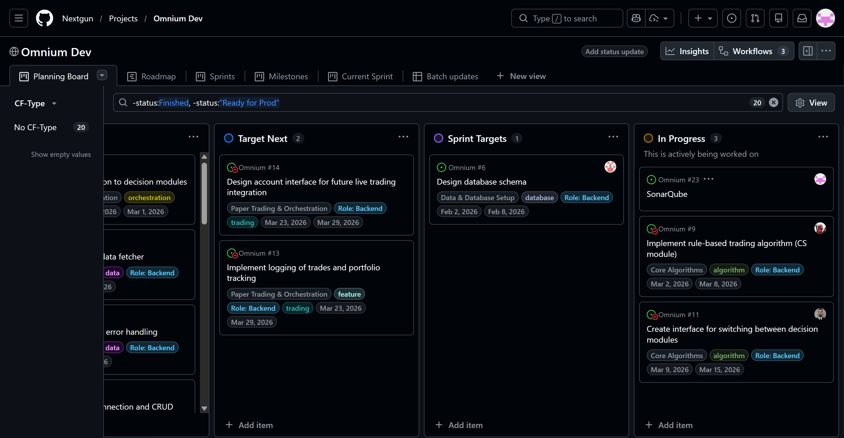
GitHub Repository
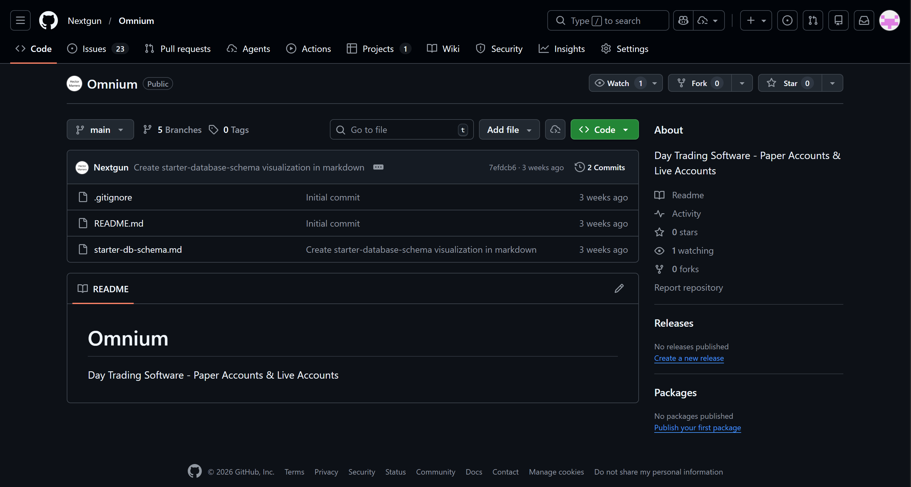

GitHub Issues
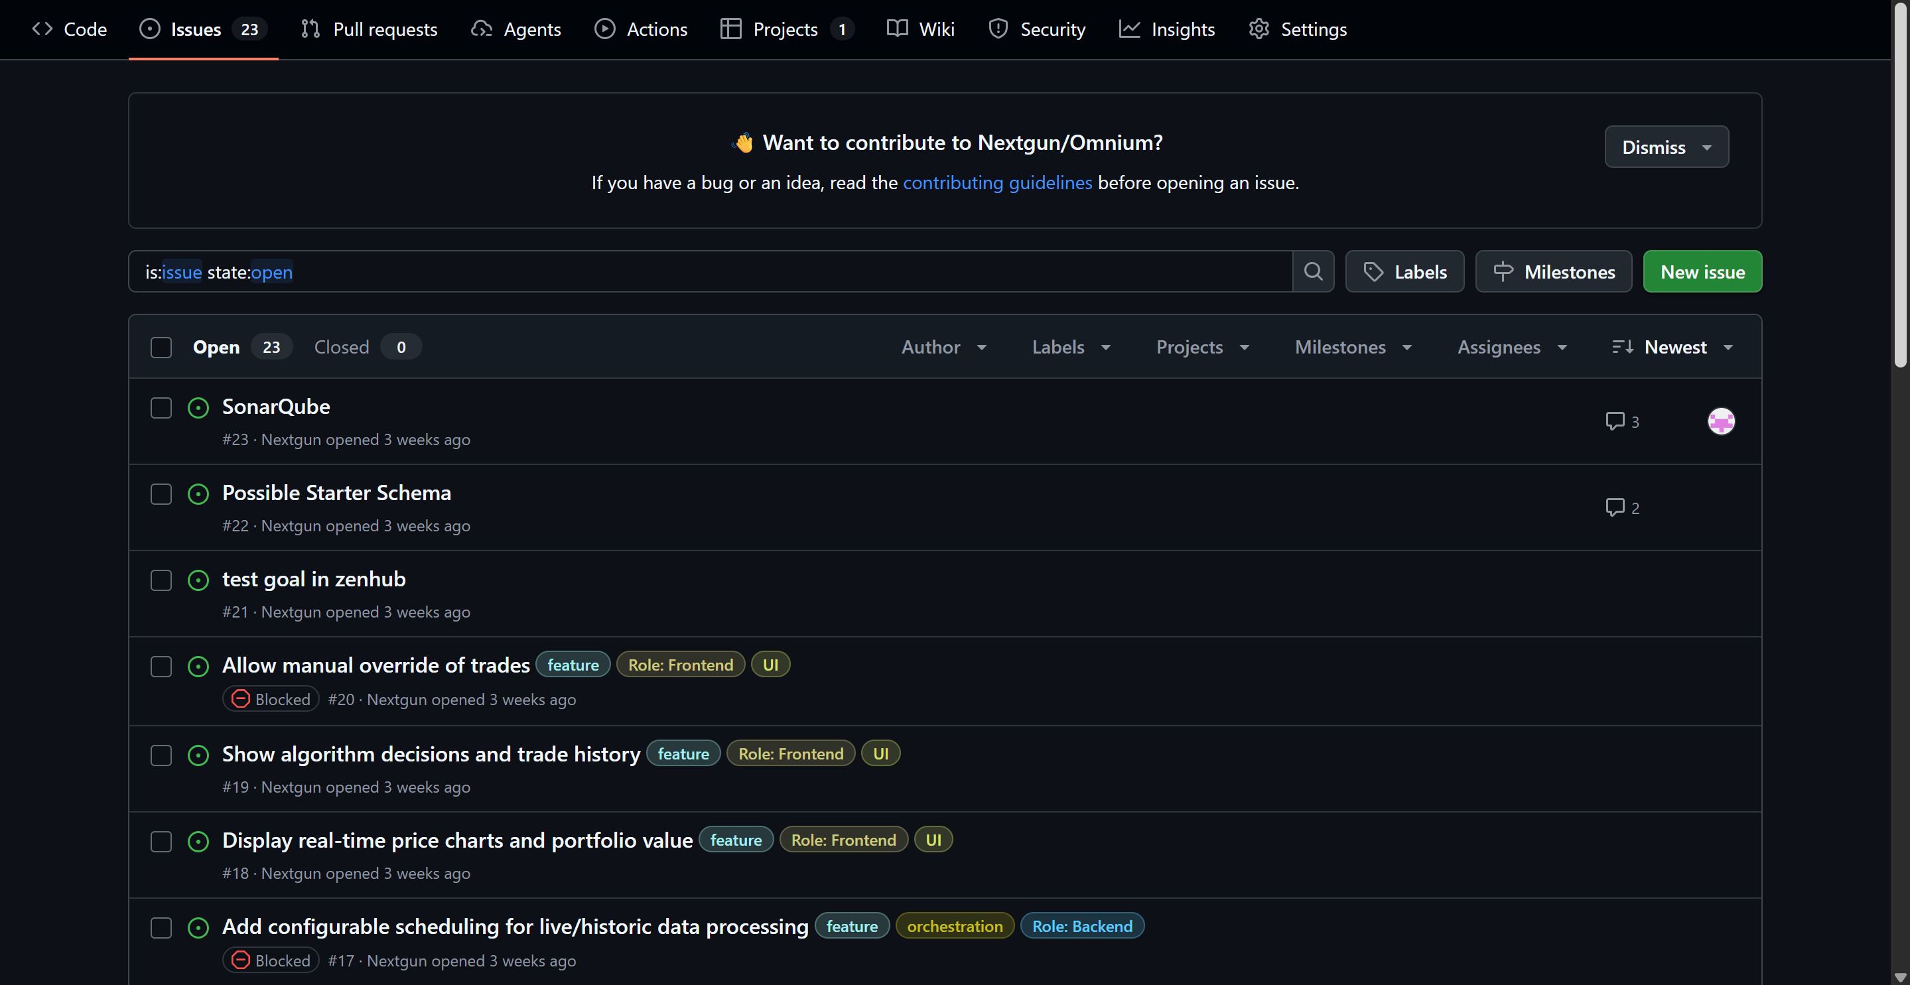
VS Code w/ cloned repository
